Diode 1N4148
CP009
Image:
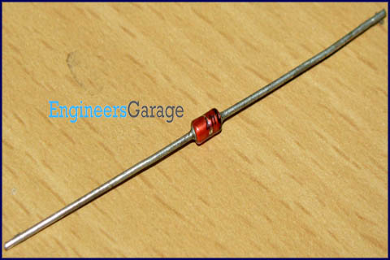
DataSheet:
1N4148.pdf
1N4148 is a high speed switching diode. The switching diodes are designed such that their reverse recovery time is very small compared to ordinary diodes. The typical switching time is 4 nsec. It comes in hermetically sealed leaded glass package. The PIV rating is 100V. The maximum repetitive peak forward current is 450 mA. Other high speed switching diode is 1N4448.

Pin Diagram:
